Monash University
Occupational Health and Safety

Risk Control Program

Reference Sheets

Monash University’s Victorian campuses are all covered by the Victorian OHS Act 1985 and its subordinate regulations and codes of practice.

An inherent part of all of this modern OHS legislation is the requirement for workplaces to undertake risk assessments on all of its activities which may impact the health and safety of the employees, visitors, contractors and students.

The risk assessment process outlined in the reference sheets enclosed are designed to assist assessment teams to follow the standard risk assessment process of Identification, Assessment & Control for all of the major hazard groups that are present at Monash University.

The major hazard groups are:

- Manual Handling Hazards
- Equipment & Process Hazards
- Chemical Exposure Hazards
- Biological Exposure Hazards
- Radiation Exposure Hazards

By reviewing your work area and activities against each of the major hazard groups, a comprehensive assessment will be produced that incorporates all of the OHS legislative requirements and University standards.

The reference sheets have been designed to allow assessment teams to quickly and comprehensively identify and assess the hazards in the workplace, rank them in terms of priority and provide guidance for the development of appropriate control measures.

The greatest amount of time and energy should be spent on selecting an appropriate control measure and instigating it. One person from within the group should be responsible for following through and ensuring the controls are put in place by the work area or support services as appropriate.

Hazard
Identification

Risk
Assessment

Risk
Control

E1. | Bending and reaching above shoulder height or below thigh height ✓ | E6. | Repetitive forces that are placed on  the hand and fingers ✓
E2. | Twisting of the spine while lifting  | E7. | High gripping forces ✓
E3. | Repetitive or sustained awkward postures  | E8. | Handling live people or animals 
E4. | Lifting and carrying heavy, unstable or awkward loads ✓ | E9. | Environmental factors such as layout,  lighting temperature, vibration,  training, individual characteristics ✓
E5. | Pushing /pulling/holding forces that are strenuous 

 |  | Likelihood
CONSEQUENCE |  | L1  Highly Likely | L2  Likely | L3  Occasionally | L4  Unlikely | L5  Highly  Unlikely
CONSEQUENCE | C1  Major injury | Extreme | Extreme | High | High | Medium
CONSEQUENCE | C2  Severe  injury | Extreme | High | High | High | Medium
CONSEQUENCE | C3  Moderate injury | High | High | High | Medium | Medium
CONSEQUENCE | C4  Minor injury | High | Medium | Medium | Medium | Low
CONSEQUENCE | C5  Negligible  injury | Medium | Medium | Medium | Low | Low

HIERARCHY OF CONTROL

- Elimination
- Substitution
- Isolation
- Procedures and Training
- Personal Protective Equipment (PPE)

Risk Control Reference Sheet


- Manual Handling Hazards

Do you have of any of the following hazards when performing the manual handling tasks involved in your work?

E1. | Are repetitive or sustained forces present? | - Lifting, lowering, pushing, pulling, dragging, holding, supporting or restraining any object or tool  - Exerting force with one hand or one side of the body  - Gripping with the fingers pinched together or held wide apart  - Exerting force whilst in an awkward posture
E2. | Are repetitive or sustained awkward postures involved? | - Squatting, kneeling, crawling, lying, semi-lying or jumping  - Working with the hand wide apart or close together  - Standing with most of the body's weight on one leg  - Working with one or more hands above shoulder height  - Working with the wrists in excessively bent positions  - Carrying with one hand or one side of the body
E3.  Identification | Are repetitive or sustained movement required? | - Bending back or neck forwards or sideways more than 20 degrees  - Twisting back or neck more than 20 degrees  - Backwards bending of the back or neck more than 5 degrees  - Reaching forwards or sideways more than 30 cm or reaching behind the body  - Twisting, turning, grabbing, picking or wringing actions with the fingers, hands or arms  - Very fast movements
E4. | Is the application of high force required? | - Hitting, kicking, throwing or catching or applying sudden or unexpected forces  - Pushing or pulling objects that are hard to move or to stop  - Jumping whilst holding a load  - Exerting force in non-referred hand  - Two or more people needed to handle the load
E5. | Is the load handled unstable, unbalanced or difficult to move? | - Is the load unstable or unbalanced?  - Is the load difficult to move?  - Does the size of the load influence the risk?  - Is the load hot or cold or contain volatile materials?
E6. | Do environmental factors affect the handling? | - Radiant heat, high or low temperatures, draughts or high humidity  - Is the visual environment suitable? (lighting levels, glare issues, reflections)  - Does required protective clothing and other PPE increase the risk of musculoskeletal disorder?  - Arm/hand vibration  - Whole body vibration

 |  | Likelihood
 |  | Duration
 |  | D1  Long periods  all day  = day | D2  Long periods  the majority of the day  > ½ day | D3  Long periods  some of the day  < ½ day | D4  Short periods  frequently  <1hr | D5  Short periods  infrequently  < 1hr
 |  | Frequency
Assessment | Consequence | F1  > than 30/min | F2  > than 5/min | F3  1 to 5 per min | F4  <than 1/min | F5  Occasionally
Near maximum effort - poor posture | M1. Major injury | Extreme | Extreme | High | High | Medium
Considerable effort - poor posture | M2. Severe injury | Extreme | High | High | High | Medium
Sustained moderate effort - poor posture  Max/considerable effort - good posture | M3. Moderate injury | High | High | High | Medium | Medium
Sustained small effort - poor posture  Moderate effort - good posture | M4. Minor injury | High | Medium | Medium | Medium | Low
Small effort - good posture | M5. Negligible injury | Medium | Medium | Medium | Low | Low
NOTE: When determining the likelihood use, frequency and/or duration as the indicator. For duration the emphasis is on an increasing scale of static muscle load over periods of minutes to hours. For frequency the emphasis is on an increasing scale of repetitive muscle force over shorter periods, seconds to minutes.

Risk Control for manual handling hazards can best be accomplished by a combination of:
- Job redesign.
- Use of mechanical assistance/aids.
- Provision of specific manual handling training.
Control

Job redesign includes:
- Modifying the object or load being handled.
- Modifying the workplace layout/ workstation.
- Rearranging the material / work flow.
- Modifying the task so that different actions & movements are required to perform the task.
- Modifying the task so that a team lift can be used.
- Modify the tools & equipment used.

The focus should always be to firstly eliminate the manual handling or ergonomic hazards by job

redesign. If proves to be impractical the task should be modified or mechanical assistance should

be provide to reduce the frequency and/or the muscle force required to perform the task.

Following any modification to the task, the workplace or the introduction of mechanical assistance or aids, a review and reassessment should always be carried out to ensure no new hazards have been introduced.

Note: information, training and instruction of employees in manual handling techniques must not
be used as the sole or primary means to control the risk associated with manual handling.

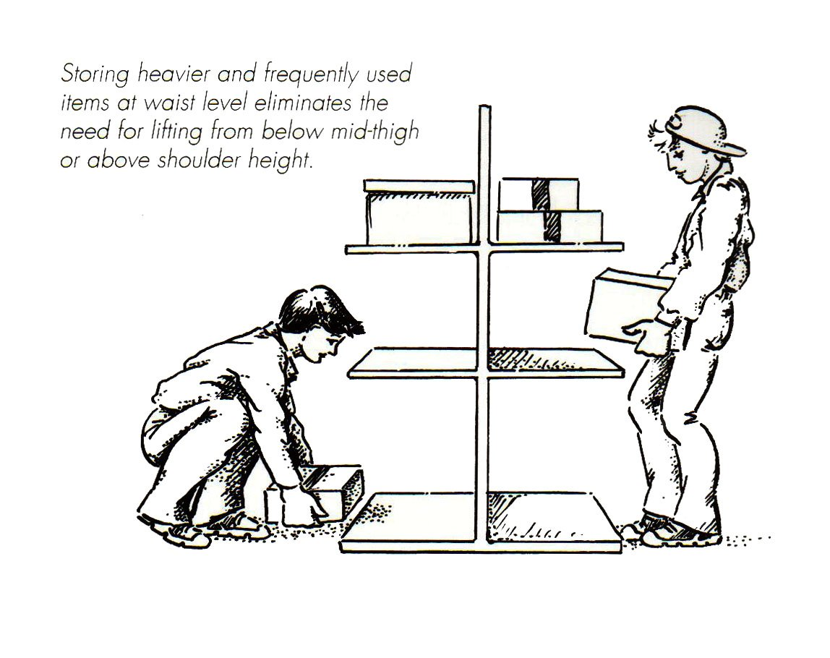

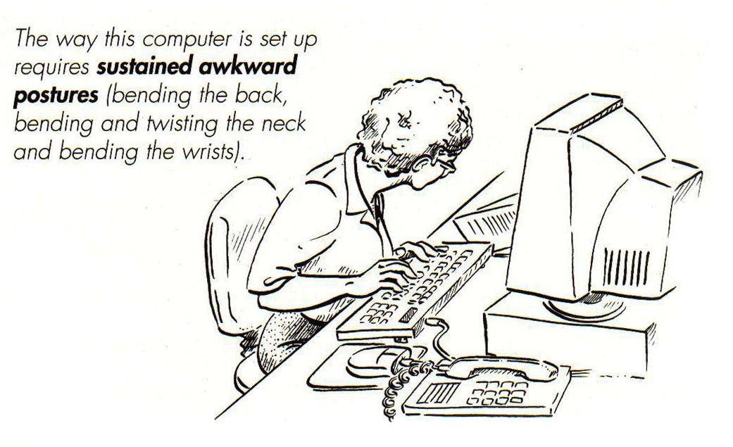

Risk Control Reference Sheet

Equipment and Processes

Do any of the equipment and processes that you use have any of the following associated hazards?

H1. | Machinery Hazard – eg. Entanglement, crushing, trapping, cutting, stabbing, shearing, abrasion, tearing? | H5. | Stored Energy Hazard – such as pressurised containers, vessels
H2.  Identification | Gravitational Hazard – such as slip, trip or fall or being hit by a falling object. | H6. | Noise or Vibration Hazards – such as exposure to noise or vibration
H3. | Kinetic Energy Hazard – such as being hit by the activities of another person or a moving vehicle or object | H7. | Thermal Hazards – such as hot /cold surfaces or components, cryogenic gases, fire, explosion, exothermic reactions.
H4. | Electrical Hazard – such as contact with an electrical conductor resulting in current flow through the body. | H8 | Hazardous Conditions- such as equipment in poor condition, unsuitable use of equipment, unsafe system of work, insufficient training.
 |  | H9. | Physico-chemical Hazards – such as corrosive or flammable chemicals, asphyxiants

 |  | Likelihood of injury after current controls are considered
 | Consequence | L1.  Highly Likely | L2.  Likely | L3.  Occasionally | L4.  Unlikely | L5  Highly Unlikely
Injury resulting in death or permanent incapacity  Assessment | C1 Major Injury | Extreme | Extreme | High | High | High
Injury requiring extensive medical treatment and/or hospitalization | C2 Severe Injury | Extreme | High | High | High | Medium
Injury requiring medical treatment by health service, LMO etc. | C3 Moderate Injury | High | High | Medium | Medium | Medium
Injury requiring first aid treatment | C4 Minor Injury | High | Medium | Medium | Medium | Low
Short term discomfort | C5 Negligible Injury | Medium | Medium | Medium | Low | Low

Risk control measures for hazards associated with equipment and processes should be considered in the following priority order:
Control

Priority One – Elimination
The best way to eliminate the risk is to remove the hazardous equipment or discontinue the hazardous process.
Don’t use the equipment. Don’t use the process.

Priority Two - Substitution
Substitute the hazardous part of the equipment or hazardous part of the process with a safer option.
Find a safer piece of equipment or better way to perform the process.

Priority Three – Isolation
Isolate the people from the equipment or process. For example, put the equipment or perform the process in a booth or a separate room. Provide remote activation / control of the equipment or process.
Keep it away from people.

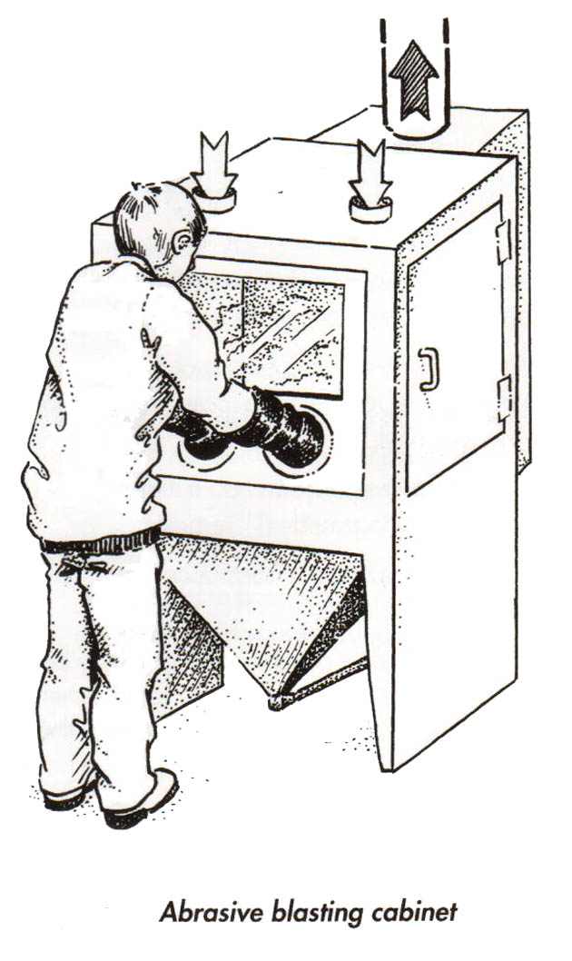

Priority Four - Engineering Controls
Engineering controls involve the use of measures to change the equipment or the environment in which the process is undertaken. Control measures can include;
- modifying the design of a piece of equipment
- modifying the workplace layout in which a process is carried out
- installing guarding to prevent exposure to the hazardous parts of a piece of equipment or process.
- providing enclosures, fume cupboards, local exhaust ventilation or automation.
Engineer a better way.

Priority Five - Procedures and Training
Systems of work or safe work procedures can often help to reduce risk associated with equipment and processes. All staff and students must be trained in the safe systems of work or safe work procedures. Periodic inspections and audits should be conducted to ensure that the systems or procedures are being followed.
Control
Examples include
- Performing the task out of normal hours or restricting access to a certain area.
- Reducing the duration or frequency staff or students perform a specific task.
- Good housekeeping.

Priority Six – Personal Protective Equipment (PPE)
PPE includes overalls, aprons, footwear, gloves, safety glasses, face shields and respirators. PPE can often be used in combination with other risk controls to further reduce exposures to hazardous parts of equipment and processes. However, if they are used as the only control measure they should be generally regarded as a short-term solution or a last resort. Staff and students must be trained in correct fit use and maintenance of the PPE. In addition, you should make sure that the equipment is the right one for the job and readily available.

Risk Control Reference Sheet

3. Chemical Exposure Hazards

Do any of your work activities or work areas have any of the following associated chemical exposure hazards?

C1. | Chemicals manually used in an open process | C2. | Chemicals /emissions generated from a process or equipment

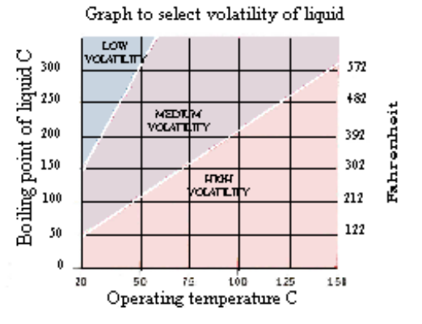
Step 1. Gather the following information about the chemicals or emissions.
Identification
- Chemical Name
- Chemical ingredients
- Risk phrases stated on containers or MSDS
- Hazard Group
- Amount used or generated
- Dustiness or volatility
- Controls in place to reduce exposures

Note: Where multiple or non-commercial compounds are used and no information is available, contact your safety officer or OHSE for specialist advice.

Step 2. Is the chemical an inhalation hazard?

 | How volatile or dusty is the chemical during use?
Amount to be used | High Dust or Aerosol  High Volatility | Medium Volatility | Medium Dust or Aerosol | Low Dust or Aerosol Low Volatility
High (tonne or m³) | Very High | High | High | Moderate
Medium (kg or litre) | High | High | Moderate | Moderate
Small (g or ml) | Moderate | Moderate | Low | Low
Very Small (mg or µl) | Low | Low | Negligible | Negligible
Micro (µg or < µl) | Low | Negligible | Negligible | Negligible

Step 3. How likely is it that the chemical will be inhaled?
Assessment of Inhalation Exposure

 | Inhalation Potential
Control | Very High | High | Moderate | Low | Negligible
Room Ventilation - general dilution | Highly Likely | Highly Likely | Likely | Unlikely | Unlikely
Open air – wind dispersion | Highly Likely | Likely | Occasionally | Occasionally | Unlikely
Appropriate Respirator | Likely | Occasionally | Occasionally | Unlikely | Highly Unlikely
Local exhaust ventilation | Occasionally | Occasionally | Unlikely | Unlikely | Highly Unlikely
Fume cupboard | Unlikely | Highly Unlikely | Highly Unlikely | Highly Unlikely | Highly Unlikely

Step 4. Determine the risk of inhaling the chemical.

 |  | Likelihood of inhalation after current controls are considered
 | Health Effect | L1.  Highly Likely | L2.  Likely | L3.  Occasionally | L4.  Unlikely | L5  Highly Unlikely
Hazard Group E | C1 Major | Extreme | Extreme | High | Medium | Low
Hazard Group D | C2 Severe | Extreme | High | Medium | Medium | Low
Hazard Group C | C3 Moderate | High | Medium | Low | Low | Low
Hazard Group B | C4 Minor | Medium | Medium | Low | Low | Low
Hazard Group A | C5 Irritant | Medium | Medium | Low | Low | Low

Step 5. Does chemical have a Skin Notation? If so determine the risk of skin absorption of the chemical:
Assessment of Skin Exposure

 |  | Likelihood of injury after current controls are considered
 |  | Will have or very likely to have direct contact with the chemical. | Likely to have chemical contact due to splashes. | May have chemical contact due to splashes occasionally. | Unlikely to have contact with chemical | Highly unlikely to have any contact with liquid
 | Health Effect | L1.  Highly Likely | L2.  Likely | L3.  Occasionally | L4.  Unlikely | L5  Highly Unlikely
Hazard Groups D or E | C1 Major | Extreme | Extreme | High | Medium | Low
Hazard Group C | C2 Severe | Extreme | High | Medium | Low | Low
Hazard Groups A or B | C3 Moderate | High | Medium | Low | Low | Low

Risk controls are actions taken to control risks to the health and safety of staff and students. The primary duty is to eliminate any risk to health arising from the use of a hazardous substance or chemical. Where elimination of risk is not practical, you must reduce the risk as far as practicable. Risk control measures for hazards associated with hazardous substances should be considered in the following priority order:
Control

Priority One –Elimination

Eliminating the risk by eliminating the use of a hazardous substance that creates the risk is the most effective way of protecting the health of staff and students. When considering the possibility of eliminating a hazardous substance you need to begin by answering questions like:
- Why is this hazardous substance used? (What is its purpose or function in the process?)
- Why is it necessary to carry out this function?
- How could this function be achieved by doing things differently?
Examples of elimination are:
- Using ultra sound to clean an object instead of a solvent
- Using a physical fastening system instead of a solvent based adhesive.
Don’t use the hazardous substance. Don’t use the process.

Priority Two – Substitution/Reduction
Substitute the hazardous substance a safer option or less hazardous form. Use less of the hazardous substance.
Examples of substitution are:
- Using water based paint instead of solvent based paint.
- Using pellets or a slurry instead of a powder
Find a safer substance or better way to perform the process.

Priority Three – Isolation

Isolation involves separating people from the substance by distance or barriers to prevent or reduce exposure. Barriers may take the form of a totally closed system or process, an enclosure with exhaust extraction or an isolated / restricted access room.
Keep it away from you.

Priority Four - Engineering Controls
Engineering controls are physical controls (such as equipment) that eliminate or reduce the generation of substances, suppress or contain substances or limit the area of contamination in the event of spills or leaks. Engineering controls often entail partial enclosure, exhaust ventilation or automation.
Engineer a better way.
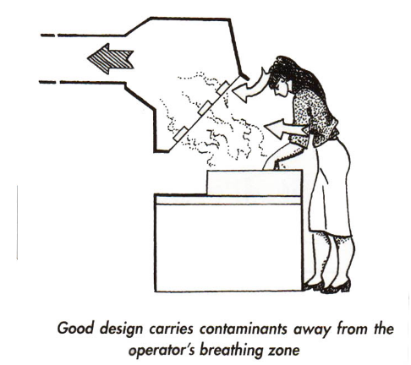

Priority Five - Procedures and Training
Systems of work or safe work procedures can often help to reduce exposure to hazardous substances
Examples include
- Performing the task out of normal hours or restricting access to a certain area.
- Reducing the duration or frequency staff or students perform a specific task.
- Good housekeeping.
- Cleaning up spills immediately

Priority Six – Personal Protective Equipment (PPE)
PPE includes overalls, aprons, footwear, gloves, safety glasses, face shields and respirators. PPE can often be used in combination with other risk controls to further reduce exposures to hazardous substances. However if they are used as the only control measure they should be generally regarded as a short-term solution or a last resort. Staff and students must be trained in correct fit use and maintenance of the PPE. In addition, you should make sure that the equipment is the right one for the job and readily available.

Hazard Group A

Risk Phrase | Skin Notation | Risk Number
Irritating to eyes | S | R36
Irritating to eyes and skin | S | R36/38
Irritating to skin | S | R38

Hazard Group B

Risk Phrase | Skin Notation | Risk Number
Harmful by inhalation |  | R20
Harmful by inhalation and in contact with skin | S | R20/21
Harmful by inhalation, in contact with skin and if swallowed | S | R20/21/22
Harmful by inhalation and if swallowed |  | R20/22
Harmful in contact with skin | S | R21
Harmful in contact with skin and if swallowed | S | R21/22
Harmful if swallowed |  | R22

Hazard Group C

Risk Phrase | Skin Notation | Risk Number
Toxic by inhalation |  | R23
Toxic by inhalation and in contact with skin | S | R23/24
Toxic by inhalation, in contact with skin and if swallowed | S | R23/24/25
Toxic by inhalation and if swallowed |  | R23/25
Toxic in contact with skin | S | R24
Toxic in contact with skin and if swallowed | S | R24/25
Toxic if swallowed |  | R25
Contact with water liberates toxic gas |  | R29
Contact with acids liberates toxic gas |  | R31
Causes burns | S | R34
Causes severe burns | S | R35
Irritating to eyes and respiratory system | S | R36/37
Irritating to eyes, respiratory system and skin | S | R36/37/38
Irritating to respiratory system |  | R37
Irritating to respiratory system and skin | S | R37/38
Toxic: danger of very serious irreversible effects through inhalation |  | R39/23
Toxic: danger of very serious irreversible effects through inhalation and in contact with skin |  | R39/23/24
Toxic: danger of very serious irreversible effects through inhalation, in contact with skin and if swallowed |  | R39/23/24/25
Toxic: danger of very serious irreversible effects through inhalation and if swallowed |  | R39/23/25
Toxic: danger of very serious irreversible effects in contact with skin |  | R39/24
Toxic: danger of very serious irreversible effects in contact with skin and if swallowed |  | R39/24/25
Toxic: danger of very serious irreversible effects if swallowed |  | R39/25
Risk of serious damage to eyes | S | R41

Hazard Group C (continued)

Risk Phrase | Skin Notation | Risk Number
May cause sensitisation by skin  Contact | S | R43
Harmful: danger of serious damage to health by prolonged exposure through inhalation and in contact with skin | S | R48/20/21
Harmful: danger of serious damage to health by prolonged exposure through inhalation, in contact with skin and if swallowed | S | R48/20/21/22
Harmful: danger of serious damage to health by prolonged exposure through inhalation and if swallowed |  | R48/20/22
Harmful: danger of serious damage to health by prolonged exposure in contact with skin | S | R48/21
Harmful: danger of serious damage to health by prolonged exposure in contact with skin and if swallowed | S | R48/21/22
Harmful: danger of serious damage to health by prolonged exposure if swallowed |  | R48/22

Hazard Group D

Risk Phrase | Skin Notation | Risk Number
Very toxic by inhalation |  | R26
Very toxic by inhalation and in contact with skin |  | R26/27
Very toxic by inhalation, in contact with skin and if swallowed |  | R26/27/28
Very toxic by inhalation and if swallowed |  | R26/28
Very toxic in contact with skin |  | R27
Very toxic in contact with skin and if swallowed |  | R27/28
Very toxic if swallowed |  | R28
Contact with acids liberates very toxic gas |  | R32
Very toxic: danger of very serious irreversible effects through inhalation |  | R39/26
Very toxic: danger of very serious irreversible effects through inhalation and in contact with skin |  | R39/26/27
Very toxic: danger of very serious irreversible effects through inhalation, in contact with skin and if swallowed |  | R39/26/27/28
Very toxic: danger of very serious irreversible effects through inhalation and if swallowed |  | R39/26/28
Very toxic: danger of very serious irreversible effects in contact with skin |  | R39/27
Very toxic: danger of very serious irreversible effects in contact with skin and if swallowed |  | R39/27/28
Very toxic: danger of very serious irreversible effects if swallowed |  | R39/28
Possible risks of irreversible effects |  | R40 - Carc cat 3
Toxic: danger of serious damage to health by prolonged exposure through inhalation |  | R48/23

Risk Control Reference Sheet - 3. Chemical Exposure Hazards (continued)

Hazard Group D (continued)

Risk Phrase | Skin Notation | Risk Number
Toxic: danger of serious damage to health by prolonged exposure through inhalation and in contact with skin | S | R48/23/24
Toxic: danger of serious damage to health by prolonged exposure through inhalation and if swallowed |  | R48/23/25
Toxic: danger of serious damage to health by prolonged exposure in contact with skin | S | R48/24
Toxic: danger of serious damage to health by prolonged exposure in contact with skin and if swallowed | S | R48/24/25
Toxic: danger of serious damage to health by prolonged exposure if swallowed |  | R48/25
May impair fertility |  | R60
May cause harm to the unborn child |  | R61
Possible risk of impaired fertility |  | R62
Possible risk of harm to the unborn child |  | R63
Harmful: possible risk of irreversible effects through inhalation |  | R40/20
Harmful: possible risk of irreversible effects through inhalation and in contact with skin |  | R40/20/21
Harmful: possible risk of irreversible effects through inhalation, in contact with skin and if swallowed |  | R40/20/21/22
Harmful: possible risk of irreversible effects through inhalation and if swallowed |  | R40/20/22
Harmful: possible risk of irreversible effects in contact with skin |  | R40/21
Harmful: possible risk of irreversible effects in contact with skin and if swallowed |  | R40/21/22
Harmful: possible risk of irreversible effects if swallowed |  | R40/22

Hazard Group E

Risk Phrase | Skin Notation | Risk Number
Harmful: possible risk of irreversible effects through inhalation |  | R40/20
Harmful: possible risk of irreversible effects through inhalation and in contact with skin |  | R40/20/21
Harmful: possible risk of irreversible effects through inhalation, in contact with skin and if swallowed |  | R40/20/21/22
Harmful: possible risk of irreversible effects through inhalation and if swallowed |  | R40/20/22
Harmful: possible risk of irreversible effects in contact with skin |  | R40/21
Harmful: possible risk of irreversible effects in contact with skin and if swallowed |  | R40/21/22
Harmful: possible risk of irreversible effects if swallowed |  | R40/22
Possible risks of irreversible effects |  | R40 Mut cat 3
May cause sensitisation by inhalation |  | R42
May cause sensitisation by inhalation and skin contact |  | R42/43
May cause cancer |  | R45

Hazard Group - Undefined

Where a hazardous substance only has one or more of the risk phrases listed in the table below then treat it as a Hazard Group E chemical. Where there are other risk phrases then the hazard group of the substance should be assigned based on the other risk phrases.

Risk Phrase | Skin Notation | Risk Number
Danger of cumulative effects |  | R33
Danger of very serious irreversible effects |  | R39
Danger of serious damage to health by prolonged exposure |  | R48
May cause harm to breastfed babies |  | R64
Harmful: May cause lung damage if swallowed |  | R65

Risk Control Reference Sheet

4.1 Biological Hazards - Microbiological Exposure Hazards

Do you have any of the following hazards when working with either microrganisms (Risk Group 2, 3 or 4) or human blood and bodily fluids?
Identification

B1. | Undertake procedures or activities that could result in spills or splashes of liquids containing the microrganisms or human blood and bodily fluids. | B3. | Use any sharps that are brought into direct contact with either microrganisms or human blood and bodily fluids?
B2. | Perform procedures or use equipment that produce aerosols.

 |  | Likelihood
 | Consequence | L1  Highly Likely | L2  Likely | L3  Occasionally | L4  Unlikely | L5  Highly Unlikely
Death or an infection that is likely to significantly shorten life span or lead to total incapacitation  Assessment | C1. Major | Extreme | Extreme | Extreme | High | Medium
Severe infection or disease that has permanent health implications that significantly alter lifestyle. | C2. Severe | Extreme | High | High | Medium | Medium
Infection or disease that results in medical treatment but does not have permanent health implications. | C3. Moderate | High | High | Medium | Medium | Low
Minor infection. | C4. Minor | Medium | Medium | Low | Low | Low
Negligible infection. | C5. Negligible | Low | Low | Low | Low | Low

Risk controls are actions taken to control risks to the health and safety of staff and students. The primary duty is to eliminate any risk to health arising from the use of a microbiological hazard. Where elimination of risk is not practical, you must reduce the risk as far as practicable. Risk control measures for hazards associated with microbiological hazards should be considered in the following priority order:
Control

Priority One –Elimination

Eliminating the risk by eliminating the use of the microbiological hazard that creates the risk is the most effective way of protecting the health of staff and students. When considering the possibility of eliminating a microbiological hazard you need to begin by answering questions like:
- Why is this microbiological material used?
- Why is it necessary to carry out this function?
- How could this function be achieved by doing things differently?
Examples of elimination are: Use of an avirulent mutant.
Don’t use the biological hazard. Don’t use the process.

Priority Two – Substitution/Reduction
Substitute the microbiological hazard for a less hazardous form. Use less of the microbiological hazard.
Examples of substitution are:
- Using a risk group 1 rather than a risk group 2 organism.
- Use screened sources of human blood rather than unscreened sources of human blood.
Find a less hazardous microorganism or find a better way to perform the process.

Priority Three – Isolation
Isolation involves separating people from the microbiological hazard by distance or barriers to prevent or reduce exposure. Barriers may take the form of a totally closed system or process, an enclosure with exhaust extraction or an isolated / restricted access room.
e.g. PC2 laboratory requirements and practices.
Keep it away from you.

Priority Four - Engineering Controls
Engineering controls are physical controls (such as equipment) that eliminate or reduce the generation of airborne biological hazards, suppress or contain the potential for airborne biological hazards or limit the area of contamination in the event of spills or leaks. Engineering controls often entail partial enclosure, exhaust ventilation or automation. Engineer a better way.

Priority Five - Procedures and Training
Systems of work or safe work procedures can often help to reduce exposure to microbiological hazards
Examples include
- Performing the task out of normal hours or restricting access to a certain area.
- Reducing the duration or frequency staff or students perform a specific task.
- Good housekeeping.
- Cleaning up spills immediately

Priority Six – Personal Protective Equipment (PPE)
PPE includes overalls, aprons, footwear, gloves, safety glasses, face shields and respirators. PPE can often be used in combination with other risk controls to further reduce exposures to microbiological hazards. However if they are used as the only control measure they should be generally regarded as a short-term solution or a last resort. Staff and students must be trained in correct fit use and maintenance of the PPE. In addition, you should make sure that the equipment is the right one for the job and readily available.

Risk Control Reference Sheet

4.2. Biological Hazards – Animal / Insects

Do you have any of the following hazards when working with animals or insects ?
Identification

B4. | Direct contact with a live animal or insect that is capable of inflicting physical damage. | B6. | Contact with an animal or insect that is capable of causing poisoning or a toxic reaction.
B5. | Routine handling of large numbers of animals or insects that shed allergenic material known to cause sensitisation (e.g. grasshopper colonies). | B7. | Contact with an animal or insect, or parts thereof, that may harbour microrganisms that could result in zoonotic infections.

 |  | Likelihood
 | Consequence | L1  Highly Likely | L2  Likely | L3  Occasionally | L4  Unlikely | L5  Highly Unlikely
Death or an injury, infection or allergy that is likely to significantly shorten life span or lead to total incapacitation  Assessment | C1. Major | Extreme | Extreme | Extreme | High | Medium
Severe injury, infection or allergy that permanently significantly alters lifestyle. | C2. Severe | Extreme | High | High | Medium | Medium
Injury or infection that results in medical treatment; Allergy that does not significantly affect lifestyle. | C3. Moderate | High | High | Medium | Medium | Medium
First aid treatment, minor injury, minor infection. | C4. Minor | High | Medium | Medium | Low | Low
Bruising or short term discomfort. | C5. Negligible | Medium | Medium | Low | Low | Low

Risk controls are actions taken to control risks to the health and safety of staff and students. The primary duty is to eliminate any risk to health arising during work with animals or insects. Where elimination of risk is not practical, you must reduce the risk as far as practicable. Risk control measures for hazards associated with working with animals or insects should be considered in the following priority order:
Control

Priority One –Elimination

Eliminating the risk by eliminating the use of the animal or insect that creates the risk is the most effective way of protecting the health of staff and students. When considering the possibility of eliminating an animal or insect from your protocol you need to begin by answering questions like:
- Why is this biological system (e.g. animal or insect) used? (What is its purpose or function in the process?)
- Why is it necessary to carry out this function?
- How could this function be achieved by doing things differently?

Don’t use the biological hazard. Don’t use the process.

Priority Two – Substitution/Reduction
Substitute the animal or insect that creates the risk for a less hazardous form.
Find a less hazardous animal or insect or find a better way to perform the process.

Priority Three – Isolation

Isolation involves separating people from the animal or insect that creates the risk by distance or barriers to prevent or reduce exposure. Barriers may take the form of a totally closed system or process, an enclosure with exhaust extraction or an isolated / restricted access room.
e.g. PC2 laboratory requirements and practices.
Keep it away from you.

Priority Four - Engineering Controls
Engineering controls are physical controls (such as equipment) that eliminate or reduce the generation of airborne biological hazards, suppress or contain the potential for airborne biological hazards or control the animal that is the potential source of injury. Engineering controls often entail partial enclosure, exhaust ventilation or automation.
Engineer a better way.
e.g. Local exhaust ventilation for high exposure activities such as cage washing.
A cow crush is an example of a remote handling device to minimize the potential for physical injury.

Priority Five - Procedures and Training
Systems of work or safe work procedures can help to reduce exposure to animal or insect that creates the risk, like:
- Reducing the duration or frequency staff or students perform a specific task.
- Good housekeeping.
Priority Six – Personal Protective Equipment (PPE)
PPE includes overalls, aprons, footwear, gloves, safety glasses, face shields and respirators. PPE can often be used in combination with other risk controls to further reduce exposures to airborne allergens or to reduce the potential for direct harm due to bites, skin contact etc . However if PPE is used as the only control measure they should be generally regarded as a short-term solution or a last resort. Staff and students must be trained in correct fit use and maintenance of the PPE. In addition, you should make sure that the equipment is the right one for the job and readily available.

Risk Control Reference Sheet

5.1. Ionising Radiation – Internal Exposure Risk
Identification

Do you work with any of the following:

R1. | Unsealed sources* of radioactive material? | R2. | Unsealed sources* of radioactive materials that emit neutrons** .
* Note: an unsealed source is one in which the radioactive material may readily escape, e.g. a liquid source in a glass vial.
**For Neutron Sources - you will need to seek advice from your departmental RSO or the University RPO.

Table 1: Determining the Internal Hazard Potential
 | Total Activity Used In One Operation
Radioisotope Radiotoxicity  Group^^  Assessment | > 20,000 MBq  ( > 540 mCi) | > 2000 MBq  to  < 20,000 MBq  (> 54 mCi  to  < 540 mCi) | > 20 MBq  to  < 2000 MBq  (> 0.54 mCi to  < 54 mCi) | > 0.2 MBq to  < 20 MBq  (5.4 μCi to < 0.54 mCi) | < 0.2 MBq  ( < 5.4 μCi)
1  (Am-241) | Very High | Very High | High | Medium | Low
2  (I-125, Co-60,  Ra-226) | Very High | High | Medium | Low | Low
3a  (P-32) | High | Medium | Low | Low | Low
3b  (Co-57, Fe-55,  Na-22, P-33, S-35) | High | Medium | Low | Low | Very Low
4  (H-3, C-14, Cr-51, Tc-99m) | High | Medium | Low | Very Low | Very Low
^^ Consult AS2243.4 Table C3 for a more comprehensive listing, if your radioisotope is not listed in this
standard contact the RPO for advice.

Table 2: Determining Likelihood of Contamination
Procedure | Likelihood of Contamination | Examples
Simple storage | Highly Unlikely
Very simple wet operations | Unlikely | Using aliquots of stock solutions
Normal chemical operations | Occasionally | Analysis of simple chemical preparations.
Complex wet operations | Occasionally | Multiple operations.  Operations with complex glass apparatus.  Northern blots.
Work with volatile radioactive compounds | Likely | Using ¹⁴C-Toluene.  Performing an iodination.
Simple dry operations work | Likely | Manipulation of powders
Complex dry operations | Highly Likely | Where powders are likely to become airborne.
Work with radioactive gases | Highly Likely

Table 3. Determining the risk of internal exposure
 | Likelihood of Contamination
Hazard Potential | Highly Likely | Likely | Occasionally | Unlikely | Highly Unlikely
Very High | Extreme | Extreme | Extreme | High | Medium
High | Extreme | Extreme | High | Medium | Medium
Medium | Extreme | High | Medium | Low | Low
Low | High | Medium | Low | Low | Low
Very Low | Medium | Medium | Low | Very Low | Very Low

Risk controls are actions taken to control risks to the health and safety of staff and students. The primary duty is to eliminate any risk to health arising during work with ionising radiation. Where elimination of risk is not practical, you must reduce the risk as far as practicable.
Control
Risk control measures for hazards associated with working with ionising radiation should be considered in the following priority order:

Priority One –Elimination

Eliminating the risk by eliminating the use of the radioisotope that creates the risk is the most effective way of protecting the health of staff and students. When considering the possibility of eliminating a radioisotope from your protocol you need to begin by answering questions like:
- Why is the radioisotope being used? (What is its purpose or function in the process?)
- Could I use a non-radioactive technique?
e.g. Use a fluorescent tracer instead of a radioisotope as a biological tracer.

Don’t use the ionising radiation hazard. Don’t use the process.

Priority Two – Substitution/Reduction
Substitute the ionising radiation hazard for a less hazardous form or reduce the activity being used. The radiotoxicity rating can be used to identify lower hazard radioisotopes. You can readily calculate the minimum amount of radioisotope needed.

e.g. Use S-35, which is in radiotoxicity group 4, instead of P-32, which is in radiotoxicity group 3a.
Use P-33, which is in radiotoxicity group 3b, instead of P-32, which is in radiotoxicity group 3a

Find a less hazardous radioisotope or find a better way to perform the process.

Priority Three – Isolation

Isolation involves separating people from the ionizing radiation hazard by distance or barriers to prevent or reduce exposure. Barriers may take the form of a totally closed system or process, an enclosure with exhaust extraction or an isolated / restricted access room.
e.g. Restricting radiation use to a special secure laboratory. Keep it away from you.

Priority Four - Engineering Controls
Engineering controls are physical controls (such as equipment) that eliminate or reduce the generation of airborne ionizing radiation hazards, suppress or contain the potential for airborne ionizing radiation hazards. Engineering controls often entail partial enclosure, exhaust ventilation or automation.

Engineer a better way.
e.g. Use of a fume cupboard where there is potential for an airborne radiation hazard.

Priority Five - Procedures and Training
Systems of work or safe work procedures can often help to reduce exposure to ionizing radiation hazards.
Examples include
- Secondary containment (e.g. spill trays) to minimize the potential for spread of a spill.
- Reducing the duration or frequency staff or students perform a specific task.
- Good housekeeping.

Priority Six – Personal Protective Equipment (PPE)
PPE includes overalls, aprons, footwear, gloves, safety glasses, face shields and respirators. PPE can often be used in combination with other risk controls to further reduce exposures to radioactive contamination. However if they are used as the only control measure they should be generally regarded as a short-term solution or a last resort. Staff and students must be trained in correct fit use and maintenance of the PPE. In addition, you should make sure that the equipment is the right one for the job and readily available.

Risk Control Reference Sheet

  - Ionising Radiation – External Exposure Risk
Do you work with any of the following ionizing radiation hazards?
Identification
R3. | Unsealed radioactive sources that emit high energy beta radiation* | R6. | Radioactive materials that emit neutrons**
R4. | Unsealed radioactive sources that emit gamma radiation | R7. | X-ray equipment or sealed source
R5. | Radioactive materials that are considered to be sealed sources |  | apparatus where a "beam" is produced #
* For Beta Emitters: P-32 can present a moderate external hazard. S-35 and P-33 generally present a low external hazard, however the attached reference table should be consulted for estimated dose rates at typical distances and typical activities.
**For Neutron Sources - you will need to seek advice from your departmental RSO or the University RPO.
# If so, you will need to seek advice from your departmental RSO or the University RPO.
Note 1: Alpha Emitters do not present an external hazard
Note 2: The formula for calculating dose rates for Gamma and X-ray emitters, together with some standard dose rates for commonly used radioisotopes, is attached.

 | Duration of exposure over a one week period (7 days)
Dose Rate* | > 16 hrs & < 40 hrs | > 8 hrs & < 16 hrs | > 1 hrs & < 8 hrs | > 5 min & < 1 hrs | < 5 min
> 500 μSv/h  to < 1500 μSv/h% | Unacceptable | Unacceptable | Unacceptable | Extreme/ Unacceptable | High
> 50 μSv/h  to < 500 μSv/h  Assessment | Unacceptable | Unacceptable | Unacceptable | Extreme | Medium
>25 μSv/h  to < 50 μSv/h | Unacceptable | Extreme | High | Medium | Low
>10 μSv/h  to < 25 μSv/h | Extreme | High | Medium | Low | Low
> 5 μSv/h  to < 10 μSv/h | High | High | Medium | Low | Low
> 1 μSv/h  to < 5 μSv/h | High | Medium | Low | Low | Low
< 1 μSv/h | Low | Low | Low | Low | Low
* Equivalent dose rate is typically used for this risk assessment process.
%: Dose rates above 1500 μSv/h are present an unacceptable risk regardless of the exposure time.

Risk controls are actions taken to control risks to the health and safety of staff and students. The primary duty is to eliminate any risk to health arising during work with animals or insects. Where elimination of risk is not practical, you must reduce the risk as far as practicable. Risk control measures for hazards associated with working with animals or insects should be considered in the following priority order:
Control

Priority One –Elimination

Eliminating the risk by eliminating the use of ionizing radiation is the most effective way of protecting the health of staff and students. Consider the questions:
- Why is ionising used?
- Is it necessary to carry out this function?
- Could this function be achieved by doing things differently?
Don’t use the ionising radiation hazard. Don’t use the process.

Priority Two – Substitution/Reduction
Substitute the ionizing radiation hazard for a lower energy emitter and/or use a lower activity. e.g. Use P-33 (low energy beta emitter) instead of P-32 (high energy beta emitter)
Find a less hazardous radioisotope or use a lower activity.

Priority Three – Isolation

Isolation is separating people from the ionising radiation hazard by distance or shielding. Barriers may take the form of a totally closed system or process, an enclosure with exhaust extraction or an isolated / restricted access room. Keep it away from you.

Priority Four - Engineering Controls
Engineering controls are physical controls (such as equipment) that eliminate or reduce the ionizing radiation emission that can reach the person. Engineering controls for ionsing radiation often entail shielded enclosures with safety interlocks. Engineer a better way.
e.g. Design a remote handling device to insert a high activity source into a Mossbauer spectrometer.

Priority Five - Procedures and Training
Systems of work or safe work procedures can often help to reduce exposure to hazardous substances. Examples include:
- Reducing the duration or frequency staff or students perform a specific task.
- Performing dry runs prior to working with radiation. (i.e. do procedure without radiation first)
Priority Six – Personal Protective Equipment (PPE)
PPE includes lead aprons, footwear, gloves, safety glasses and face shields. PPE can often be used in combination with other risk controls to further reduce exposure to ionizing radiation. However if PPE is used as the only control measure it should be generally regarded as a short-term solution or a last resort. Staff and students must be trained in correct fit use and maintenance of the PPE. In addition, you should make sure that the equipment is the right one for the job and readily available.

Attachment to radiation reference sheet: Calculating Dose Rate

Γ = Gamma dose rate from 1 GBq at 1 metre
A = Activity of source in GBq
D = distance from the source in metres
Dose rate = ΓA
D²

Gamma dose rates (Γ) for a number of radioisotopes are listed in appendix C of Australian Standard 2243.4 Safety in Laboratories - Part 4 Ionizing Radiations. This can be viewed as a PDF document via the library database (Note: you must have a current authcate to access this).

Dose Rate Estimates for Some Commonly Used Gamma Emitters

Radioisotope | Γ  μSv/h from 1 GBq at 1 m | Dose Rate μSv/h From
Radioisotope | Γ  μSv/h from 1 GBq at 1 m | 1 MBq |  | 1 mCi *
Radioisotope | Γ  μSv/h from 1 GBq at 1 m | at 0.3 m | at 1m | at 0.3 m | at 1 m
Iodine-125 | 74 | 0.82 | 0.074 | 30.44 | 2.74
Chromium-51 | 6.3 | 0.07 | 0.006 | 2.59 | 0.23
Technicium-99m | 33 | 0.37 | 0.033 | 13.57 | 1.22
*Note: 1 mCi equals 37 MBq

Dose Rate Estimates for Some Commonly Used Beta Emitters

Radioisotope | Emax  MeV | Range in Air | Dose Rate  [mGy/hr at 6 cm  from 1 MBq]
Phosphorus-32 | 1.7 | 7.2 m | 2.6
Sulfur-35 | 0.167 | 0.3 m | 3.2
Hydrogen-3 (tritium) | 0.018 | < 5 mm | 4.5
Carbon-14 | 0.156 | 0.3 m | 3.3

